Rock, paper, scissors



In this project you will make Rock, Paper, Scissors in Scratch.

To have your move, you’ll take a photo of your hand.

But first, you’ll need to train the computer to look at your photos and recognise the different hand shapes of rock, paper, and scissors.

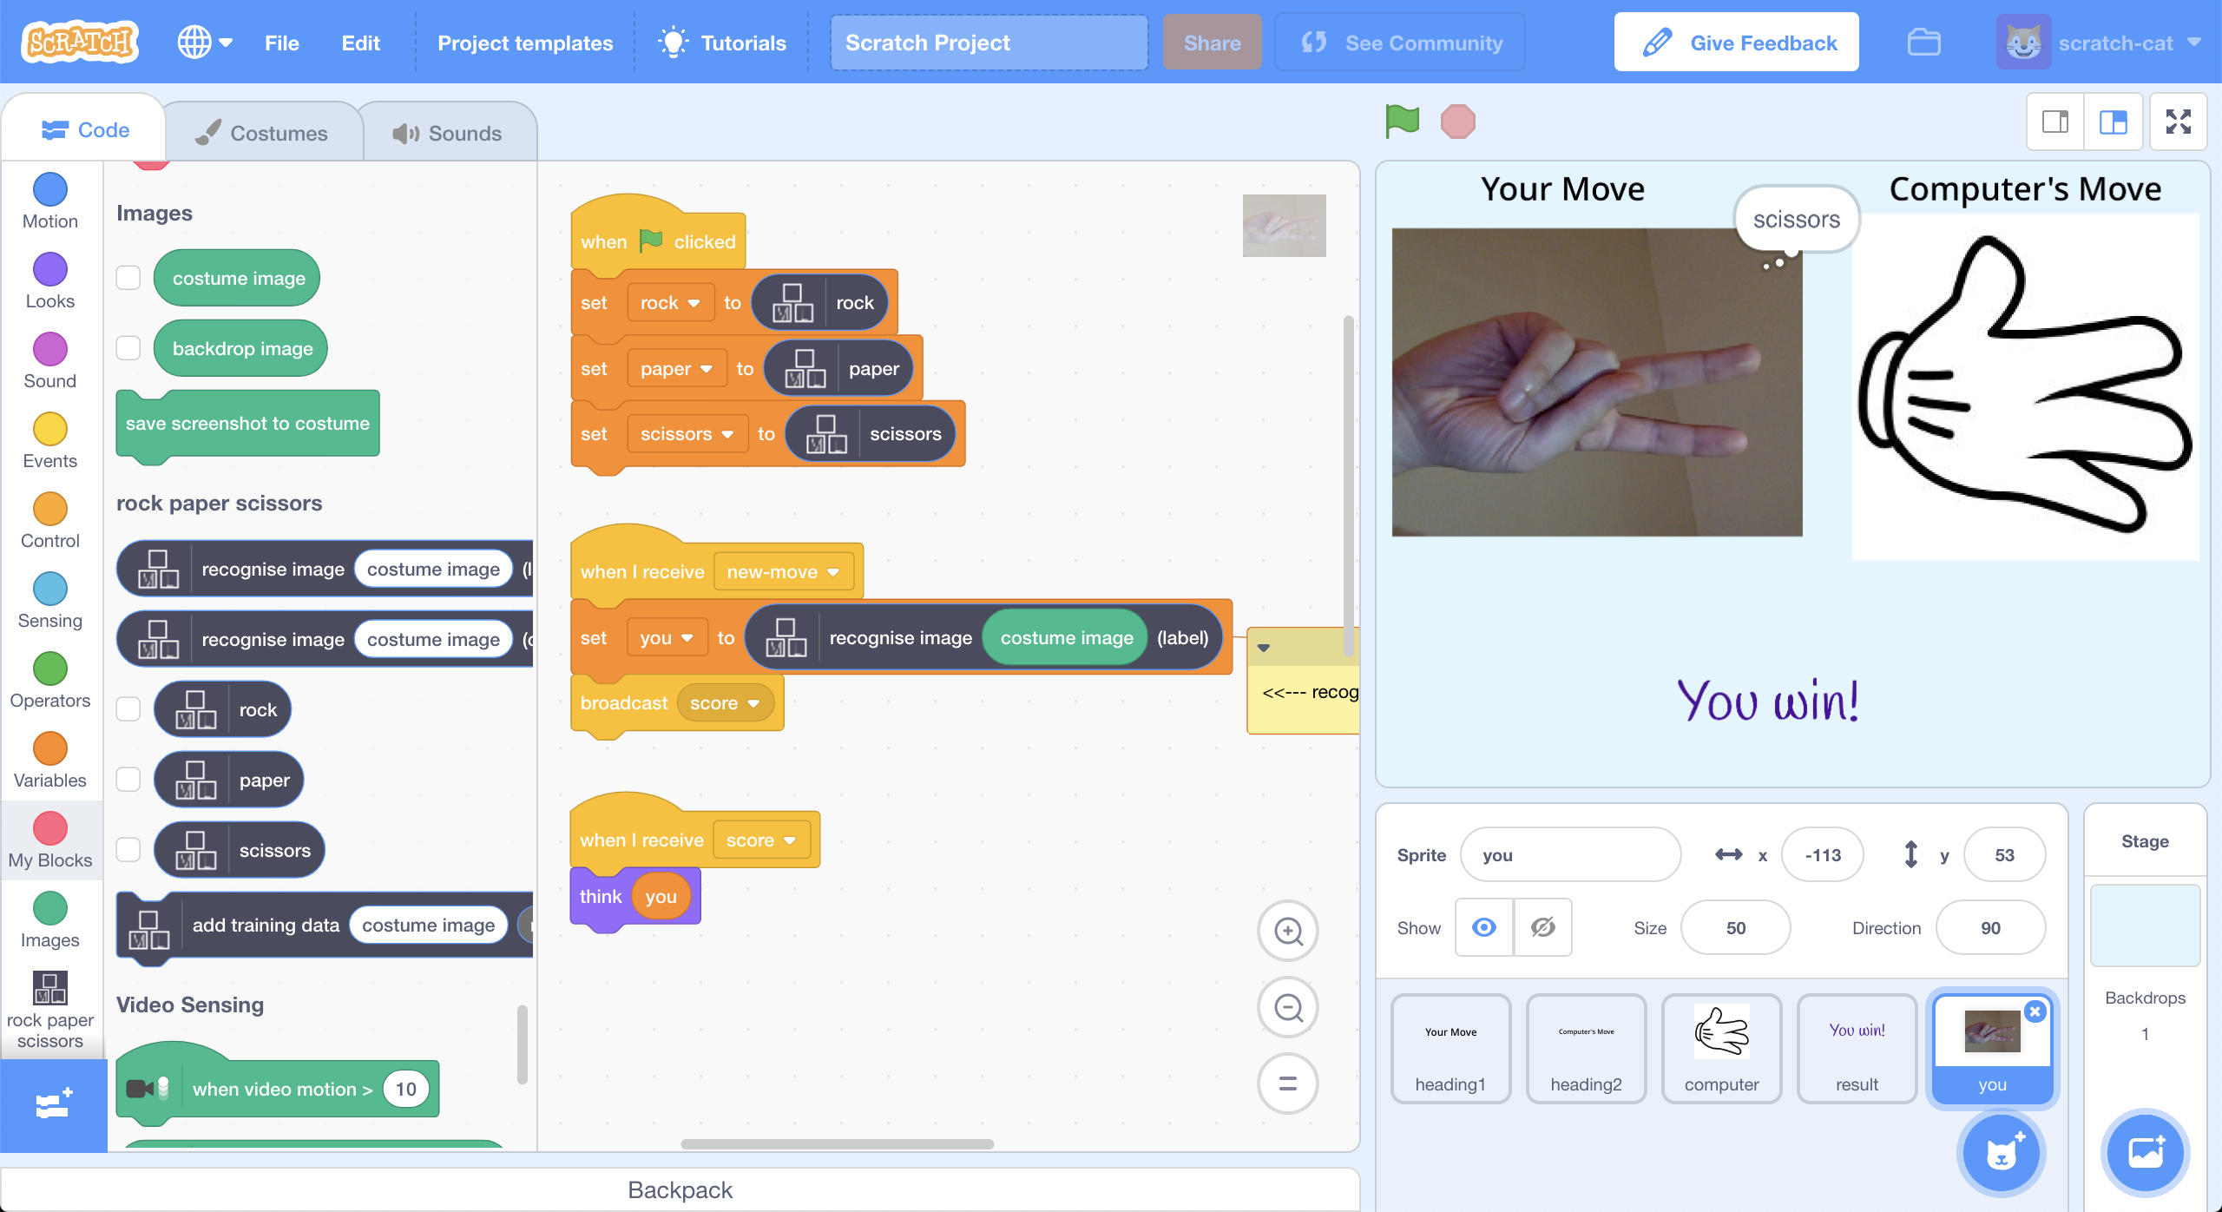

This project worksheet is licensed under a Creative Commons Attribution Non-Commercial Share-Alike License

http://creativecommons.org/licenses/by-nc-sa/4.0/

**Teacher / Group leader instructions : Setup**

**This activity will include students taking pictures of their hands & uploading them.**

If you’re not happy with that, please choose a different activity.

This version of the “Rock, paper, scissors” activity will get your class to work together to train a single machine learning model. A version of this activity where students can work individually to each train their own machine learning can be downloaded from <https://machinelearningforkids.co.uk/worksheets>

**Objective:** Create a group project & prepare it for use by your class

1. Go to <https://machinelearningforkids.co.uk/> in a web browser
2. Login using your teacher username/password
3. Click on “**Projects**” in the top menu bar
4. Click on the “**+ Add a new project**” button
5. Create a project called “rock paper scissors”, set to recognise “**images**” and make sure you tick the “**Whole-class project**” checkbox  
   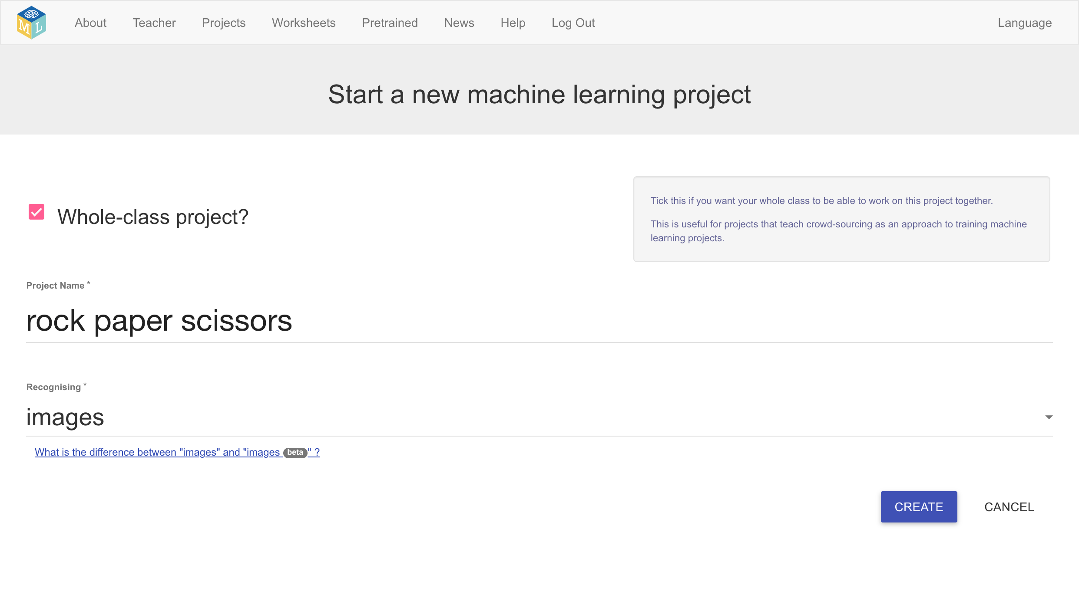
6. Click “**Create**”
7. Click on the “rock paper scissors” project in the list, and then click “**Train**”
8. Use the “**+ Add new label**” button to create training buckets for Rock, Paper and Scissors  
   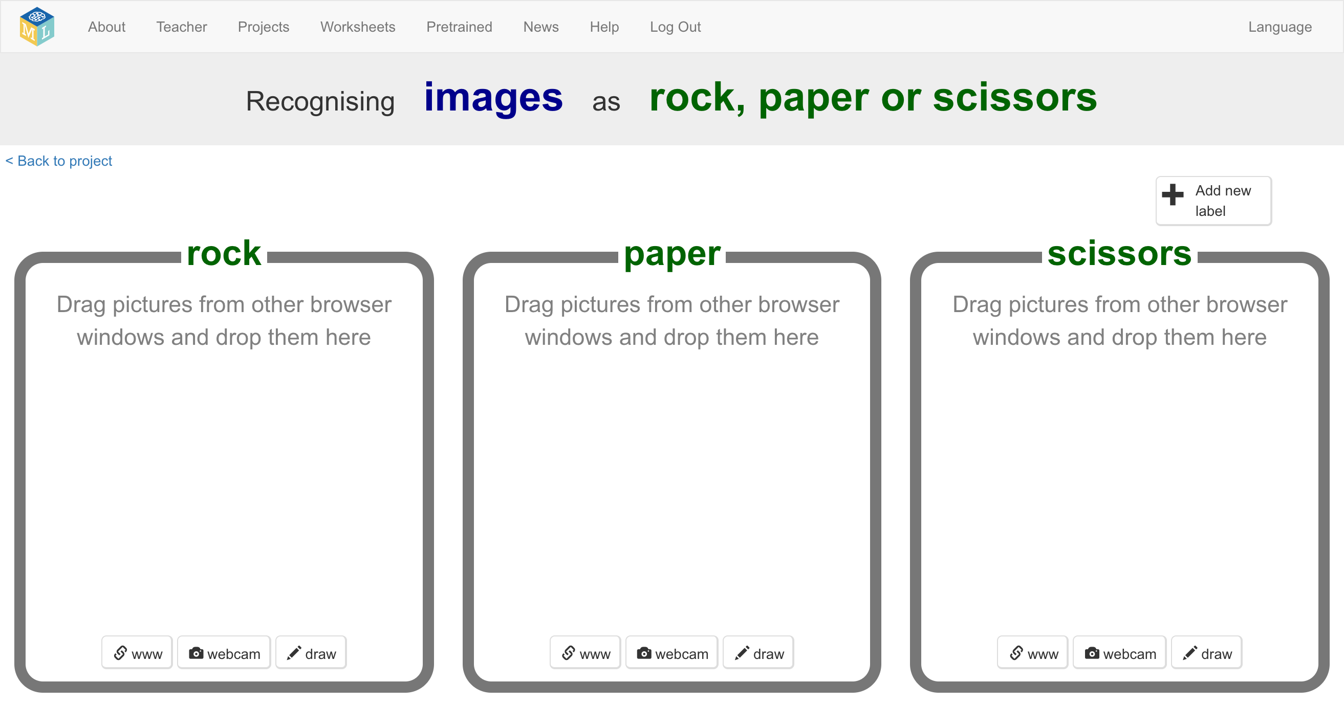

**Student instructions**

**This activity will include you taking pictures of your hand & uploading them.**

If you’re not happy with that, ask your teacher or group leader for a different activity.

1. Go to <https://machinelearningforkids.co.uk/> in a web browser
2. Click on “**Get started**”
3. Click on “**Log In**” and type in your username and password  
   *If you don’t have a username, ask your teacher or group leader to create one for you.  
   If you can’t remember your username or password, ask your teacher or group leader to reset it for you.*
4. Click on “**Projects**” on the top menu bar
5. You should see a “rock paper scissors” project created by your teacher. Click on it.  
   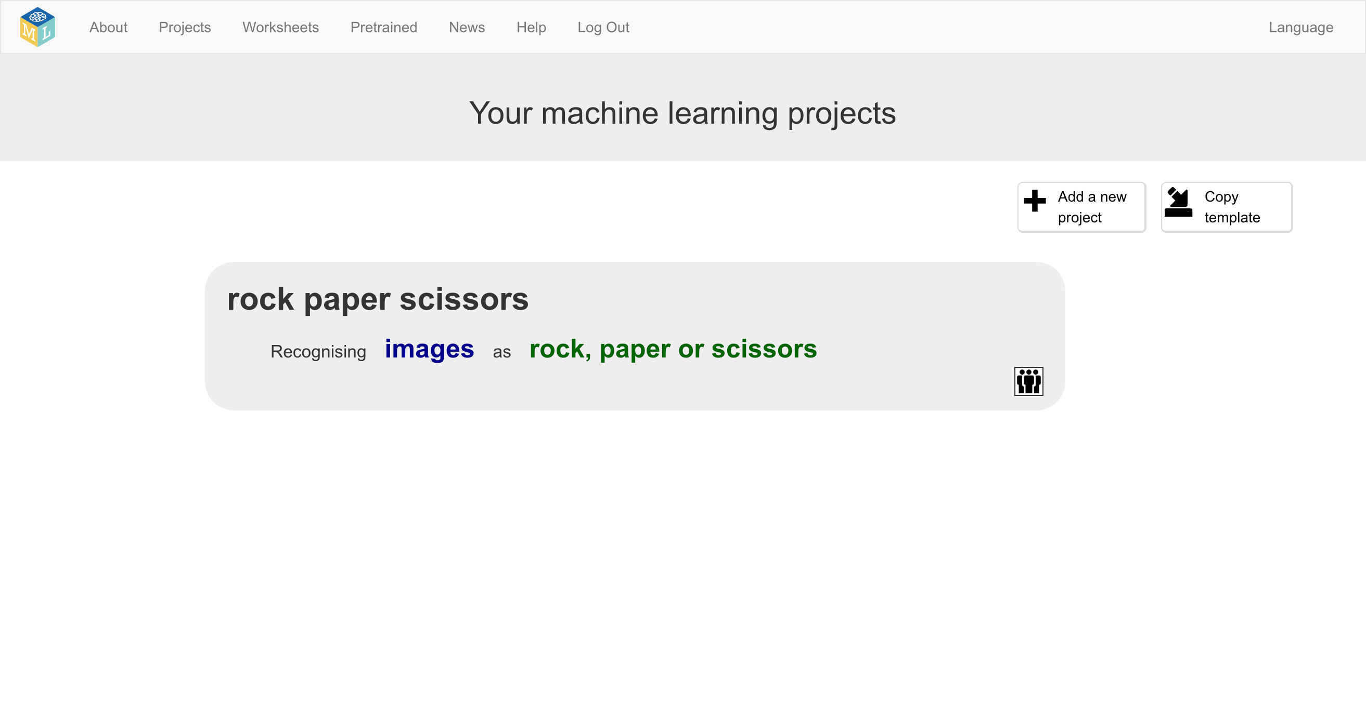
6. Click the “**Train**” button to start collecting examples of photos to train the computer with.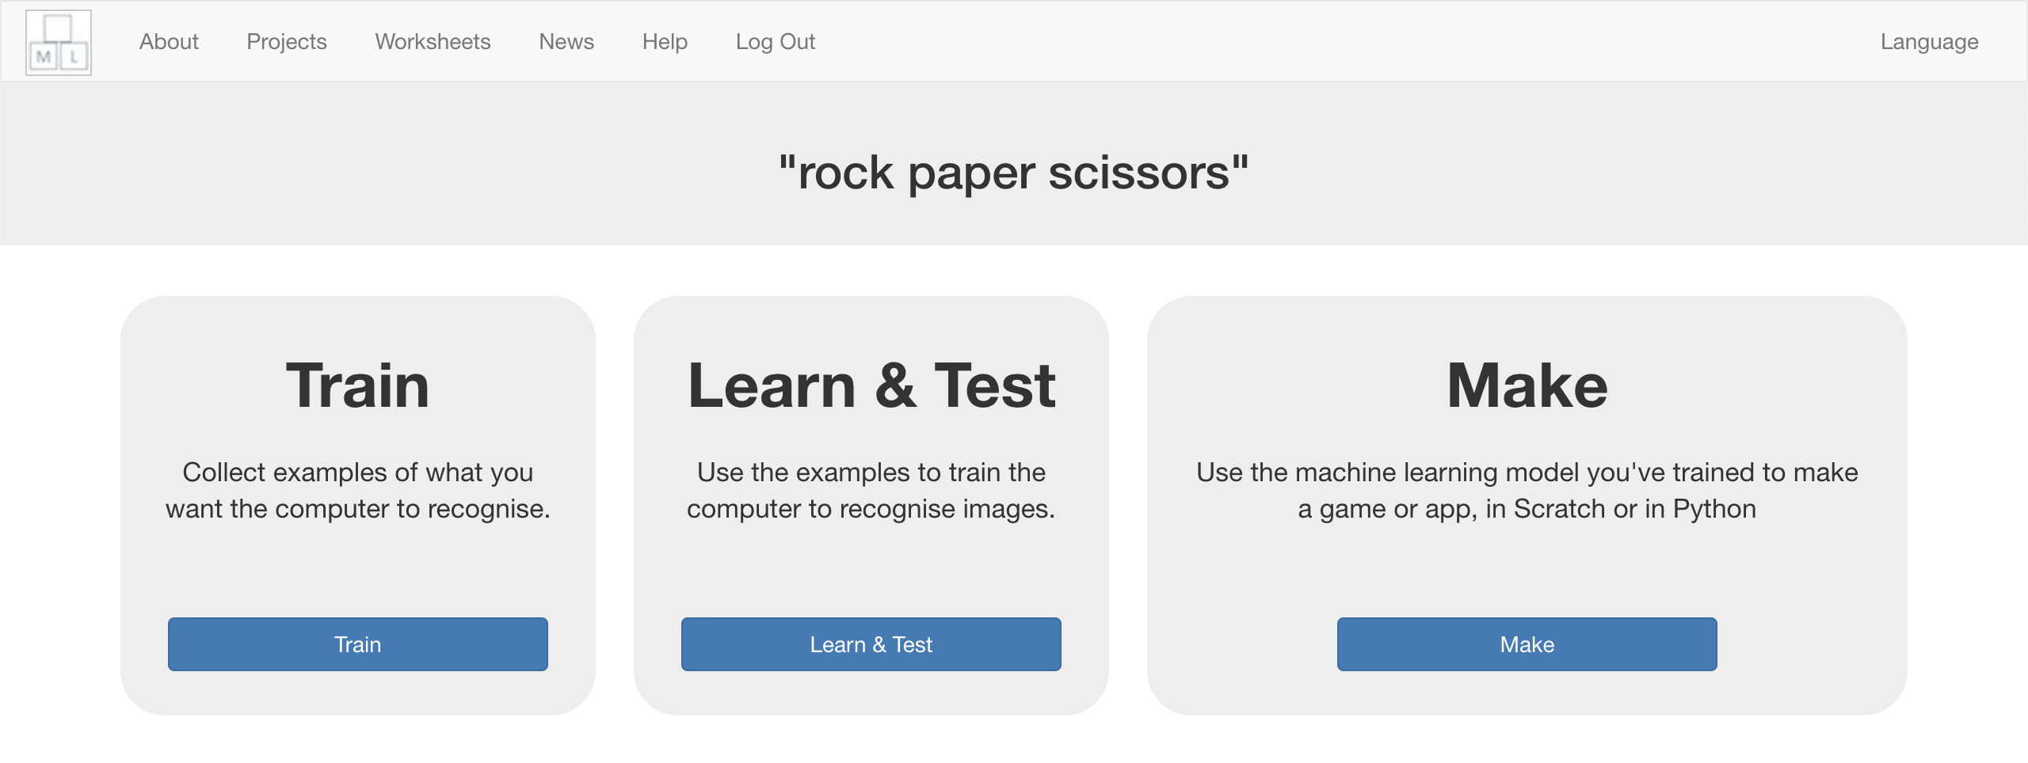
7. Your teacher has prepared training buckets for pictures.   
   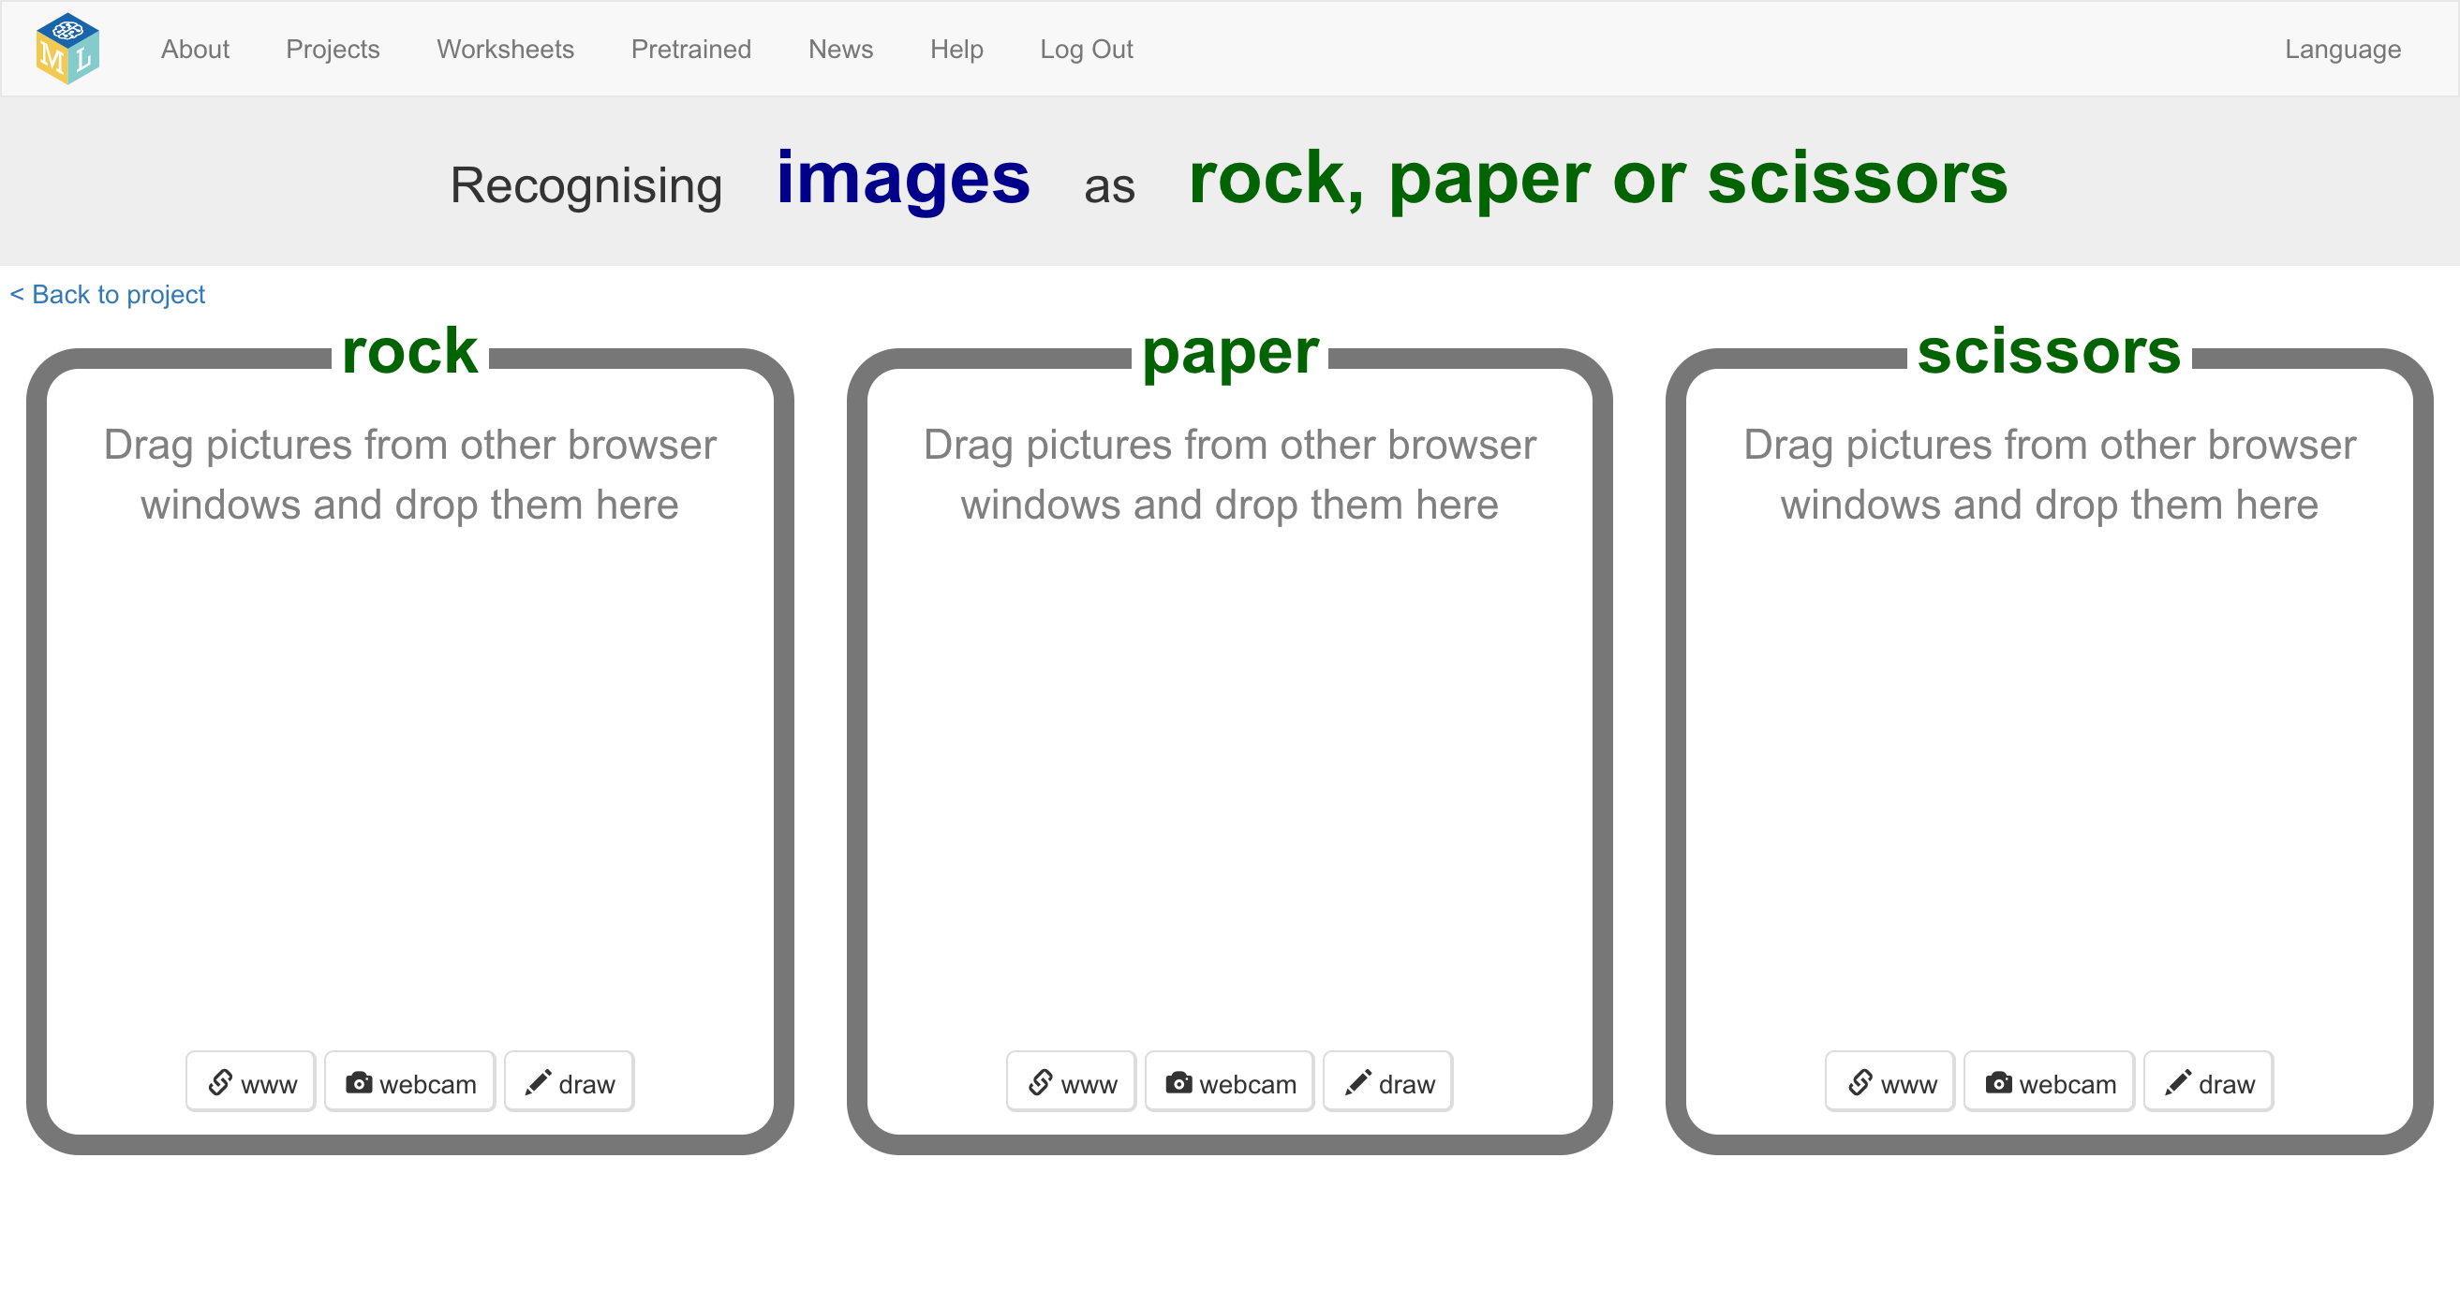
8. Click “**webcam**” at the bottom of the “rock” bucket

*A Preview window shows the current view from your webcam.*  
*You will need to click “Approve” or “Allow” if your web browser asks permission to use your webcam.*

1. Make your hand into a “rock” shape (fist) in front of the webcam  
   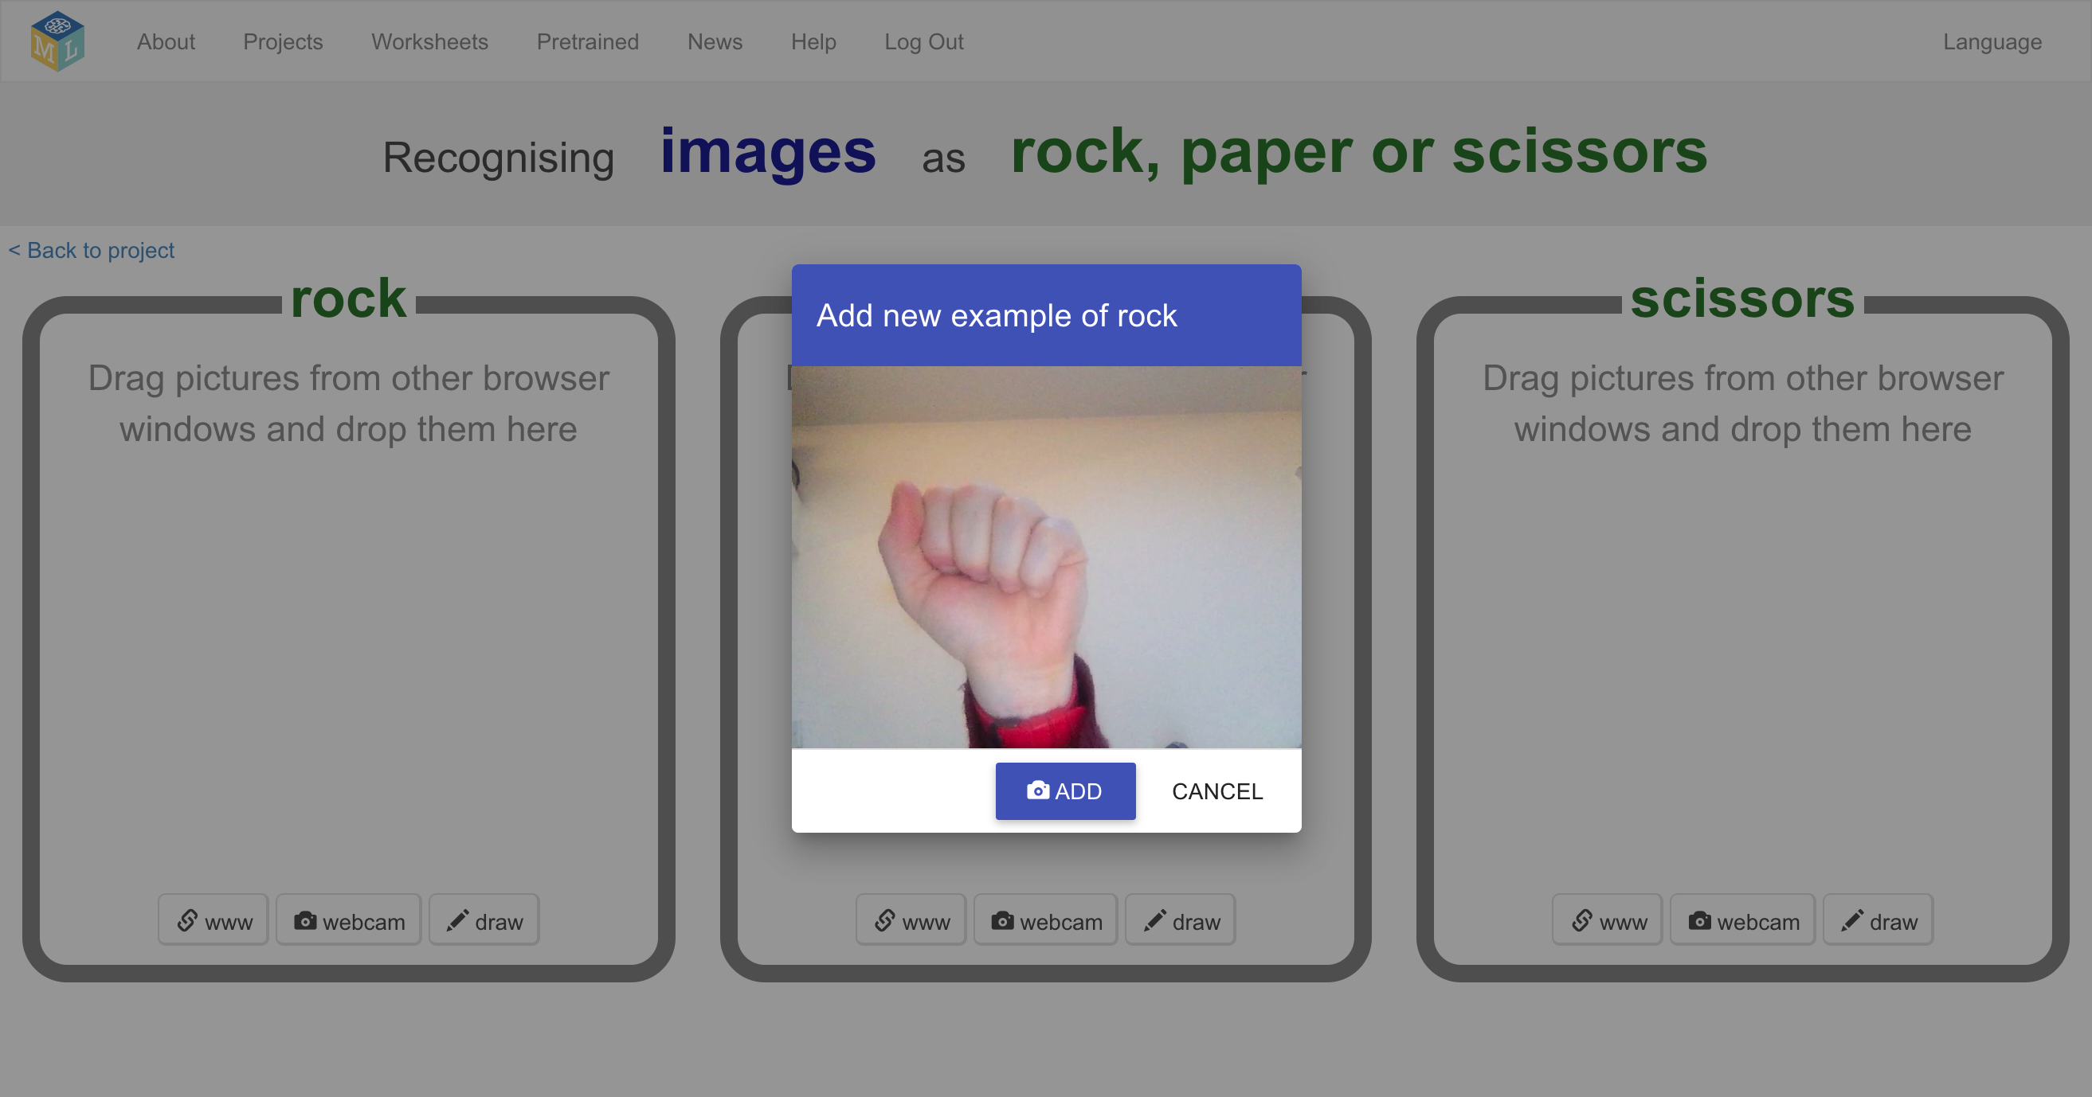
2. When you’re ready, click “**ADD**” to take a picture  
   *If you’re doing this with a partner, it might be easier for one of you to click on “ADD” while the other makes hand-shapes.*
3. Click “**webcam**” at the bottom of the “rock” bucket again  
   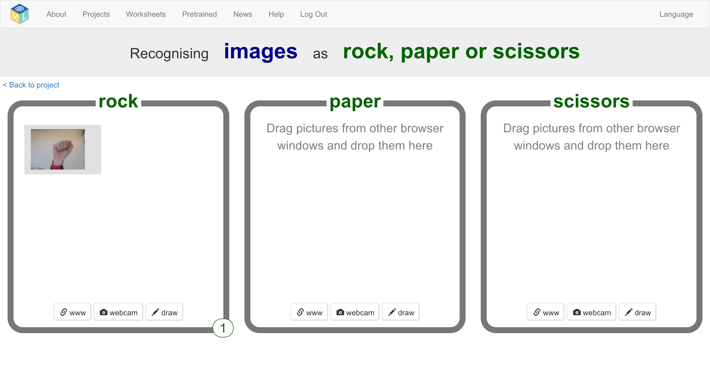
4. Repeat until you’ve got **10** examples of a “rock” shape (fist).   
   *Try to get a variety of positions, angles and sizes.   
   The more variation the computer has to learn from, the better.*  
   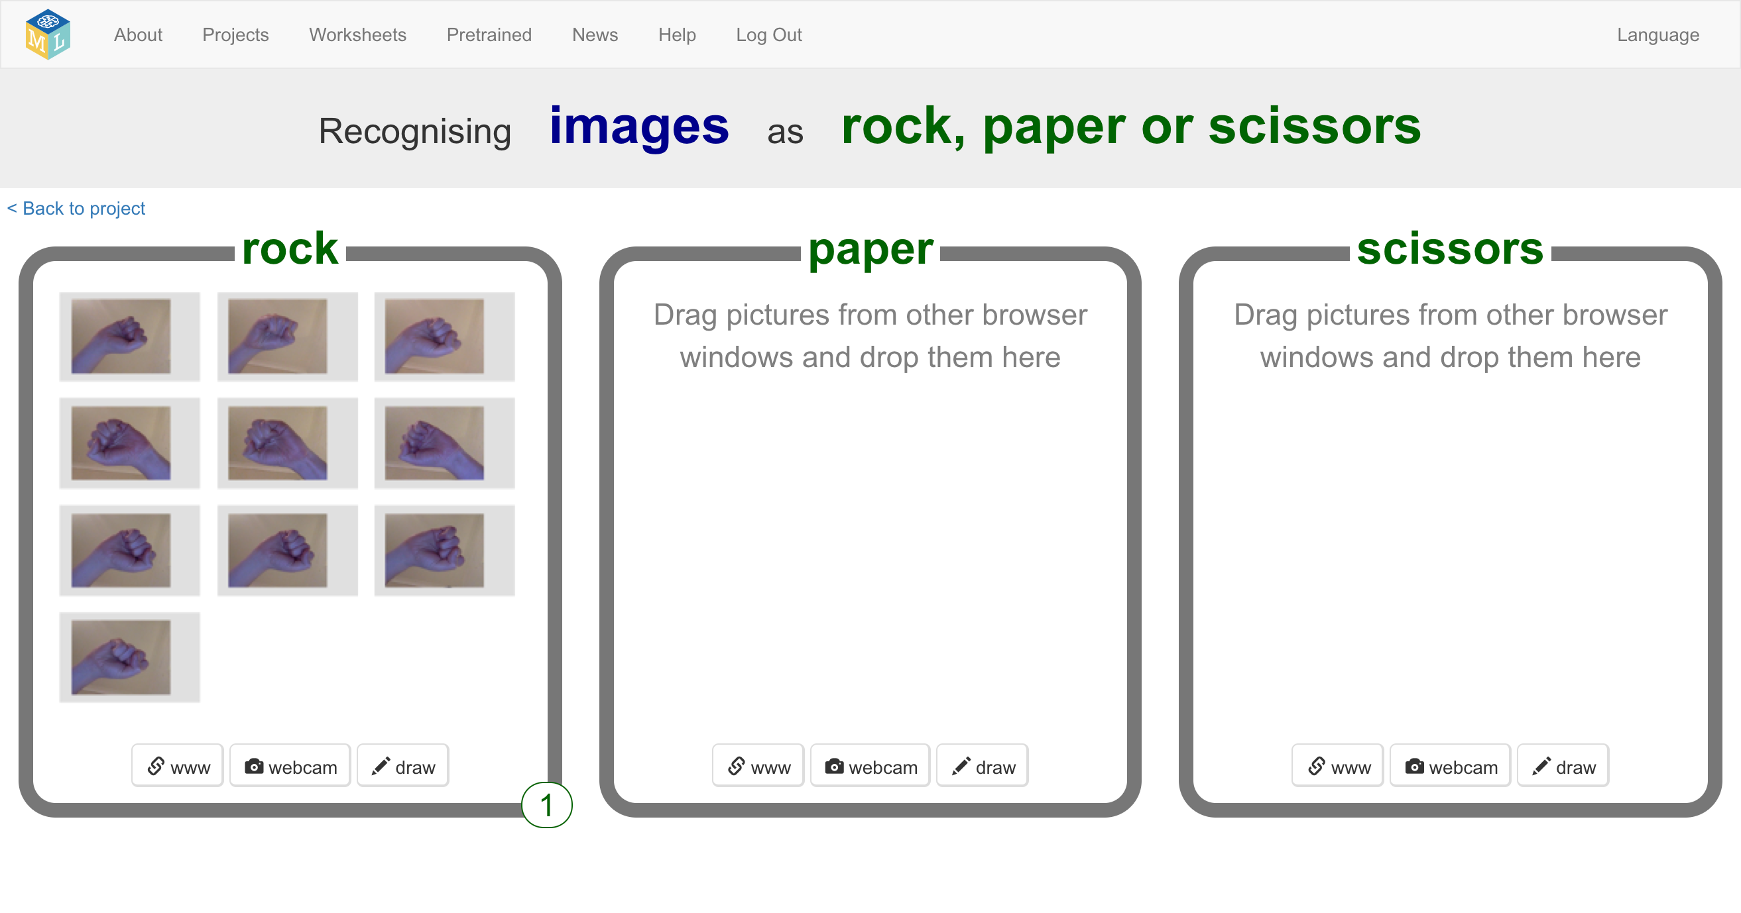
5. Click the “**webcam**” button at the bottom of the “paper” bucket
6. Click “**ADD**” for a photo of your hand in a “paper” shape (flat hand)
7. Repeat until you have **10** photos of your hand in a “paper” shape *Try to get a variety of positions, angles and sizes.  
   The more variation the computer has to learn from, the better.*  
   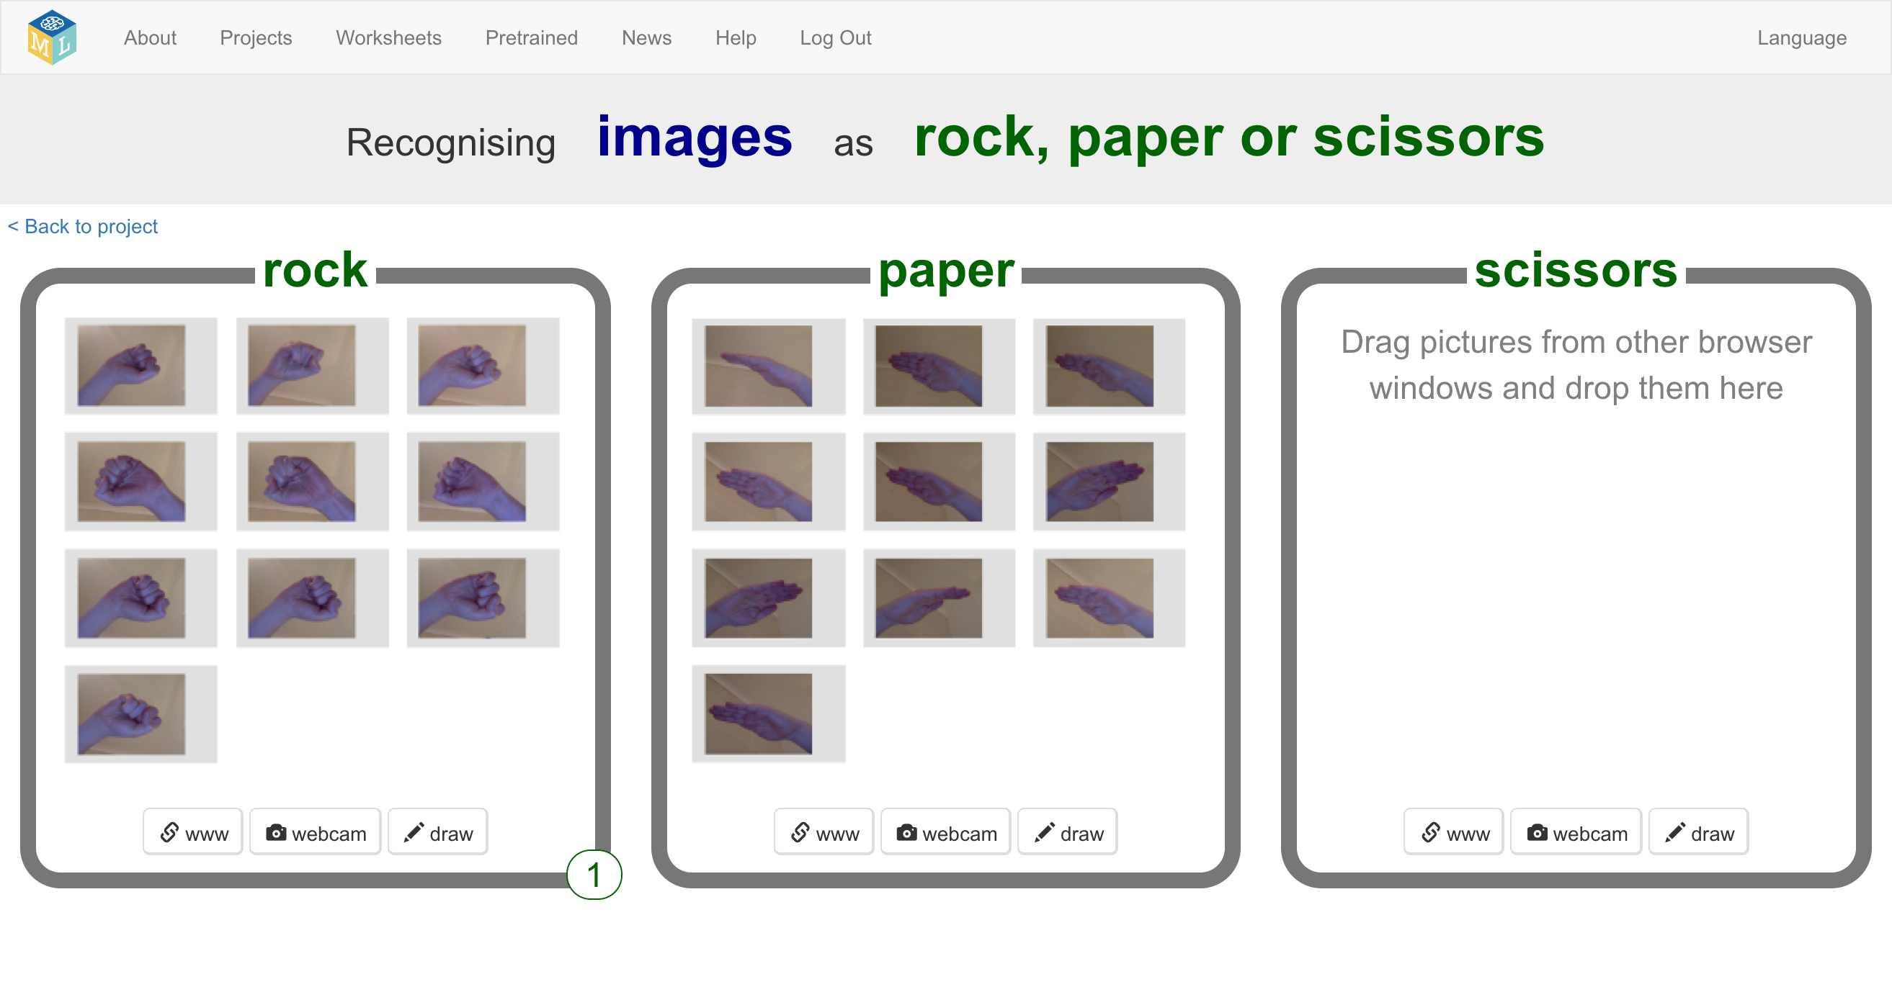
8. Use the “**webcam**” button in the “scissors” bucket to take **10** photos of your hand in a “scissors” shape (two fingers).  
   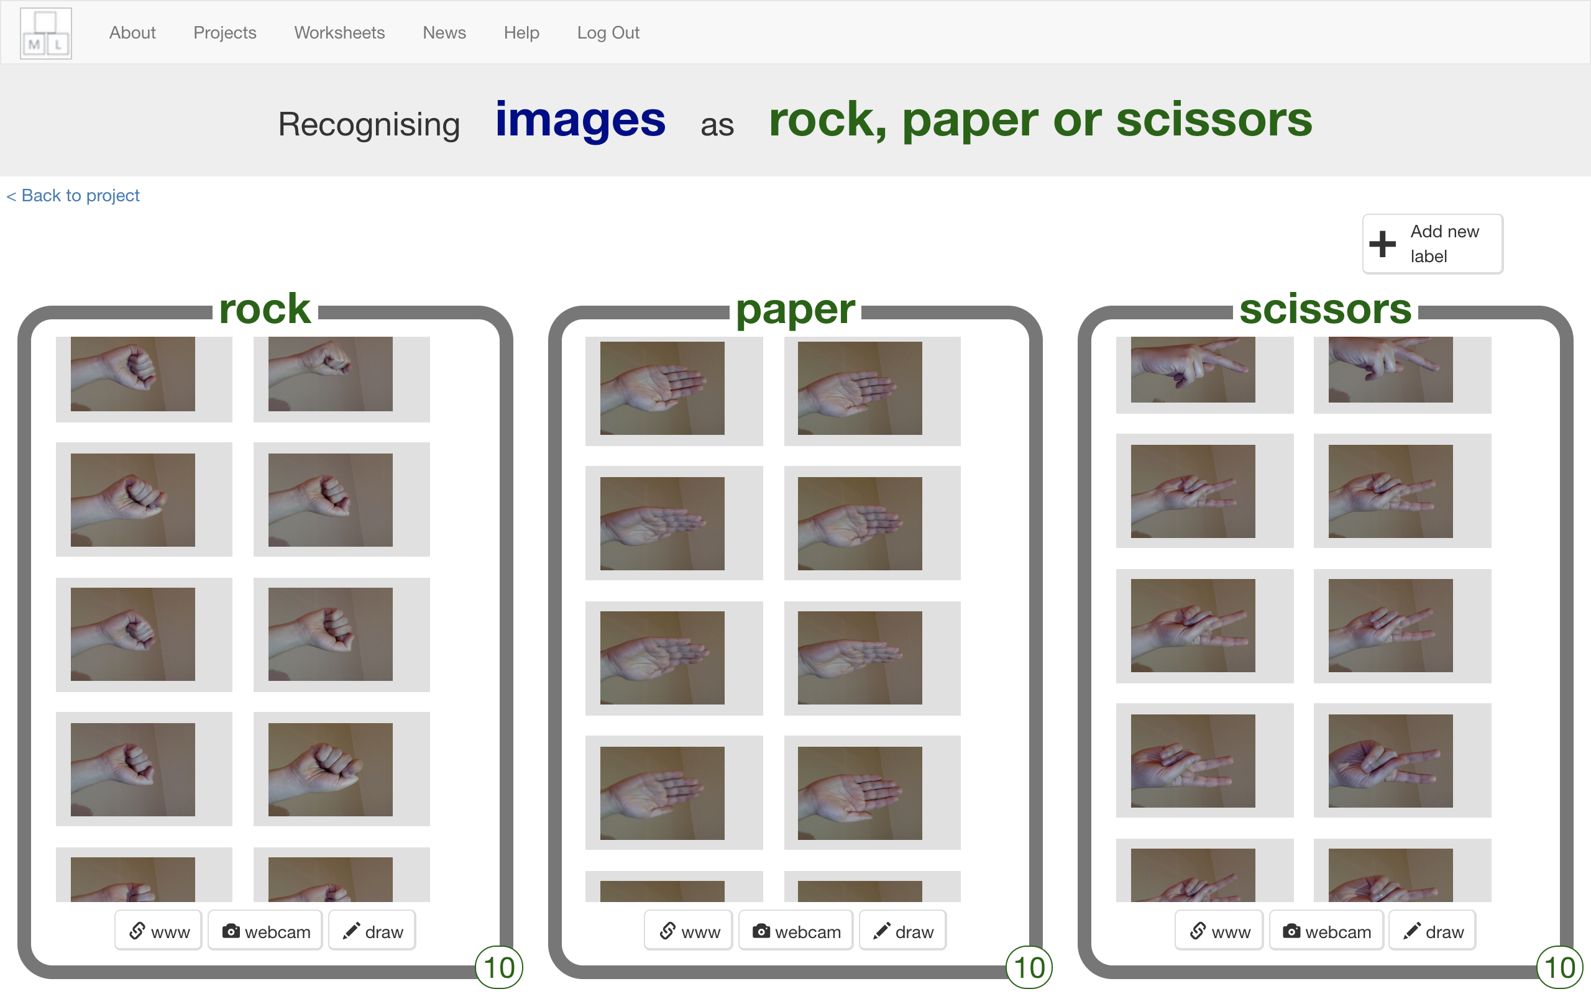
9. Your classmates will also be adding photos to the same training buckets as you, but they won’t show up while you’ve got the page open.  
   *Refresh the page to see all the training so far from the whole class.*
10. Keep going until your class have collected enough examples.  
    **Don’t move past this step until your teacher tells you that it is time to move on.**

**Teacher / Group leader instructions : Train a ML model**

**Objective:** Monitor class progress & train a machine learning model

1. Click on “**Projects**” in the top menu bar
2. Click on the “rock paper scissors” project
3. Click on the “Learn & Test” button
4. Review the summary of the progress the class has made  
   *The more examples they collect, the better the model should perform, but they need at least ten examples of each to be able to create a model at all.*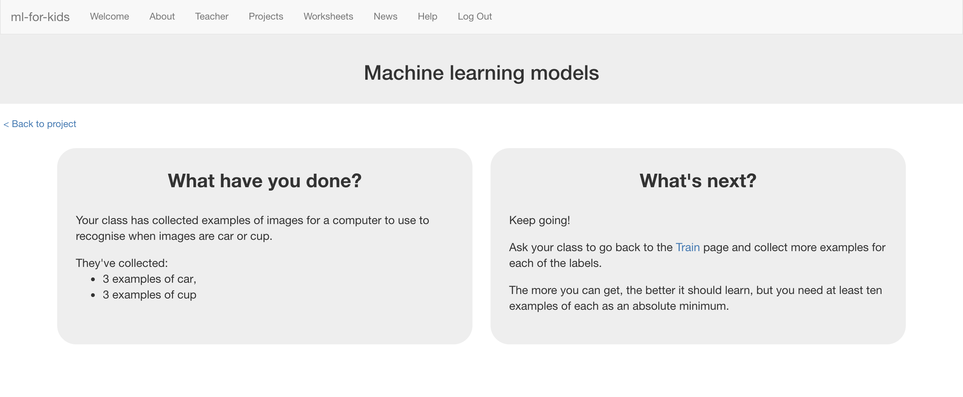
5. When you’re ready to proceed, click “Train new machine learning model” to train a new model using their examples.  
   *This may take a minute or two. The status on the page will change from “Training” to “Active” once it has finished.*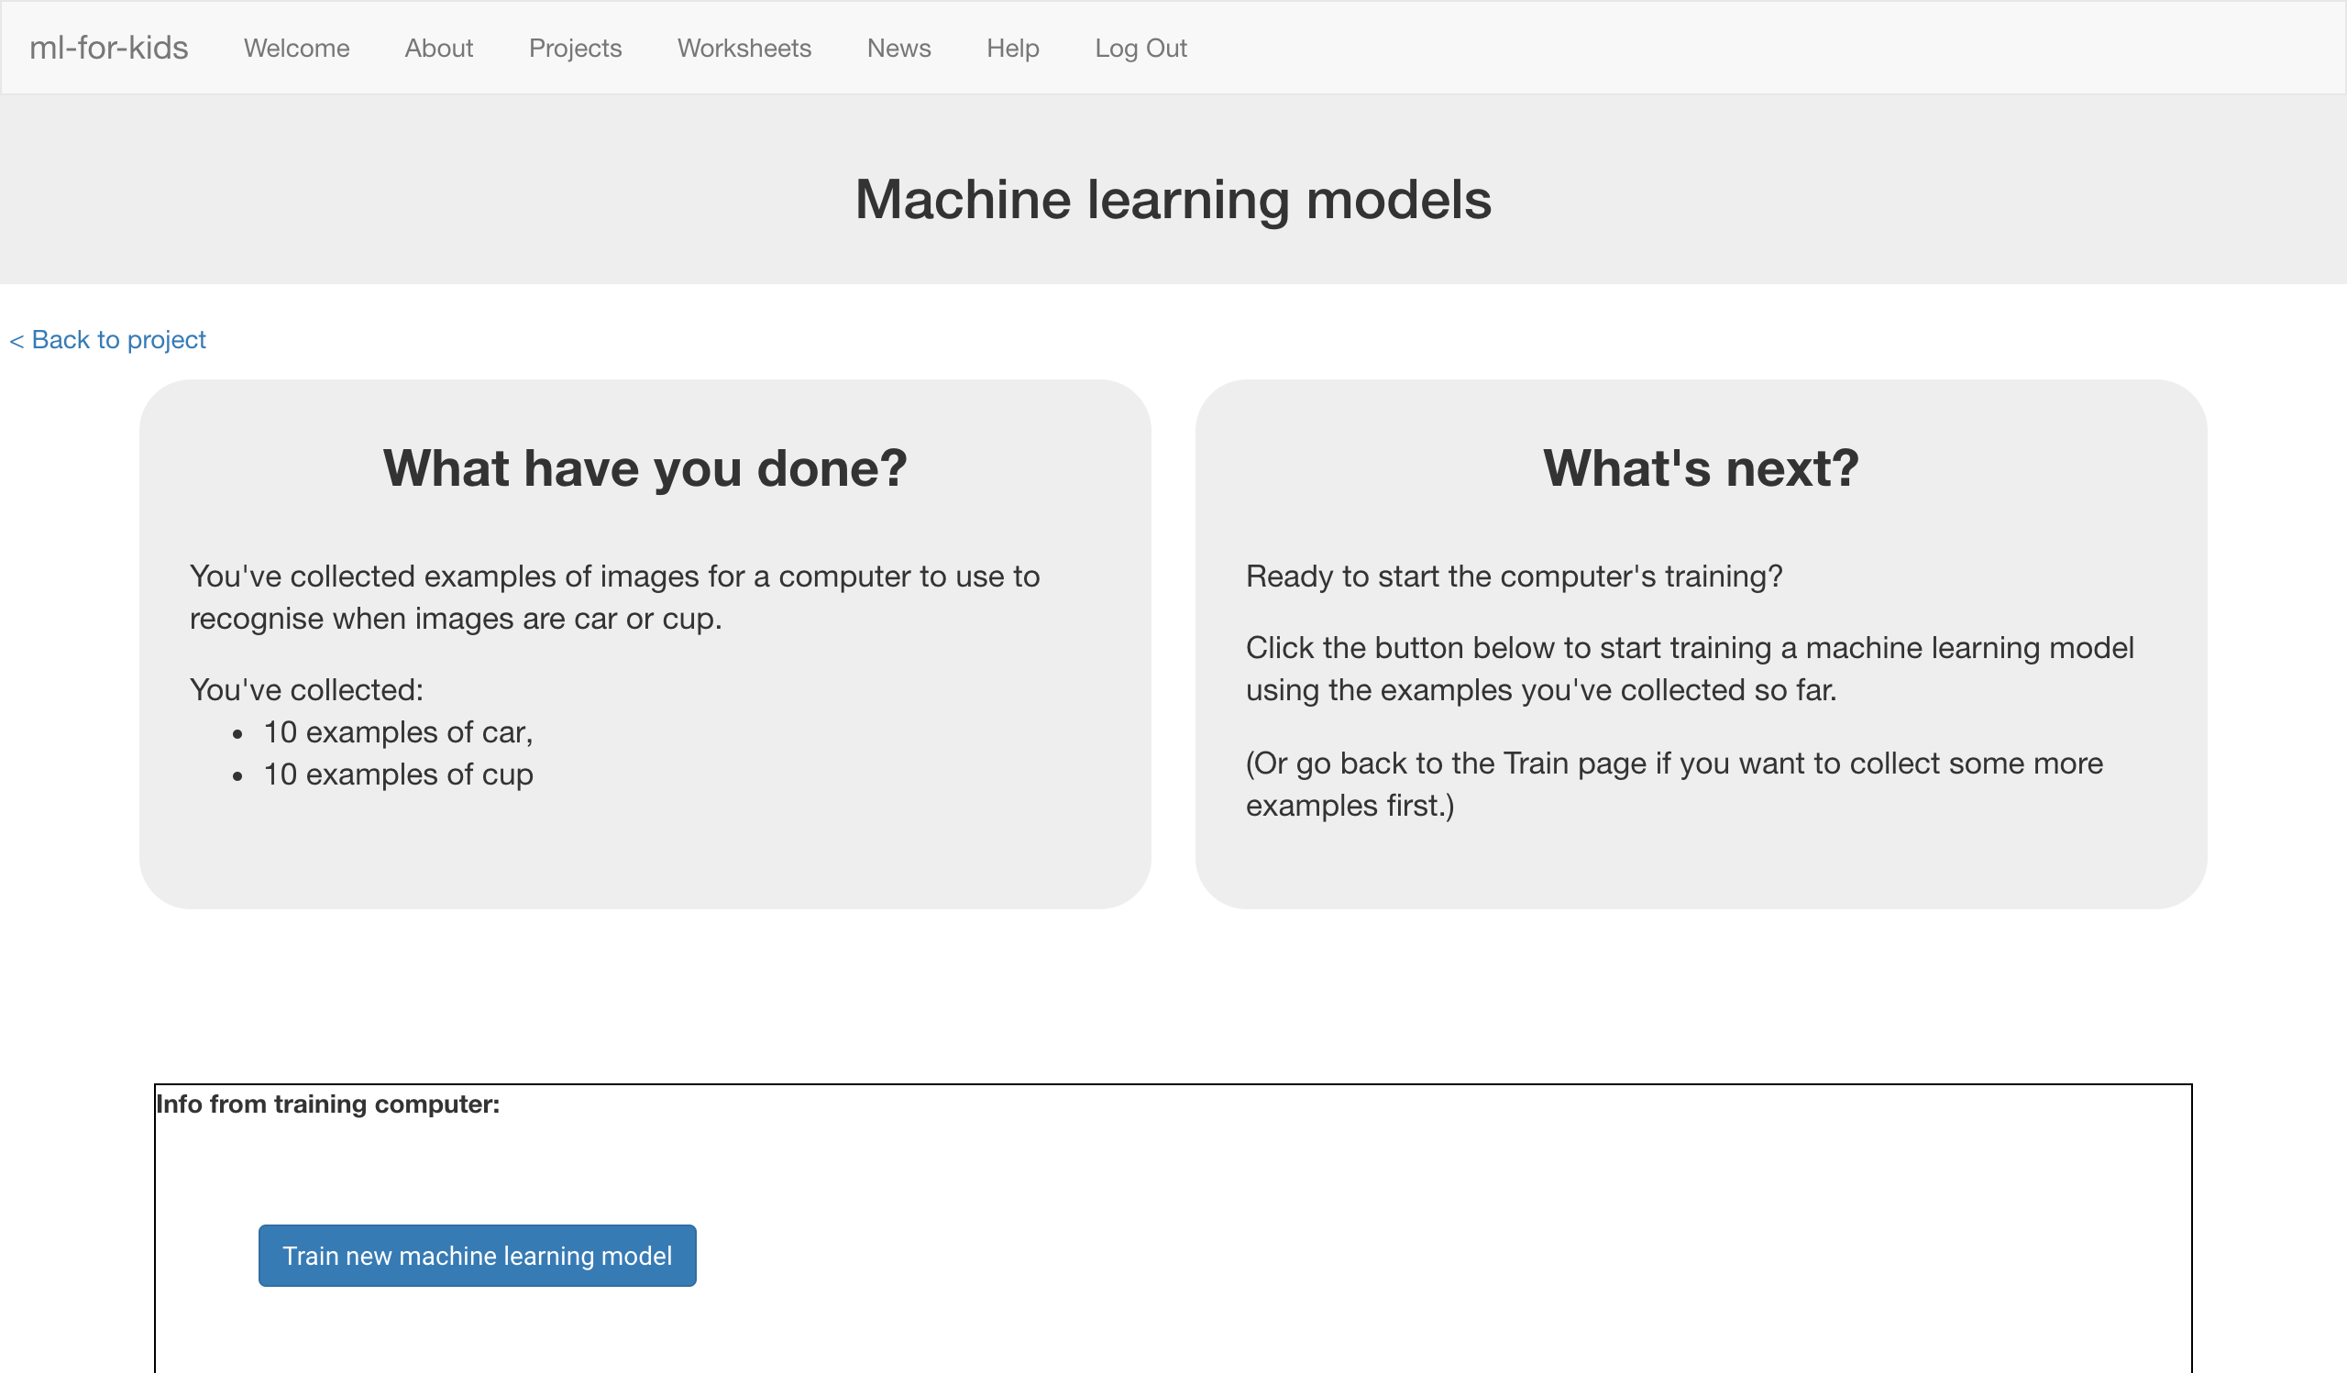
6. Once it is ready, you can tell the class it’s time to move on.

**Student instructions**

1. Click the “**< Back to project**” link.
2. Your teacher has used the examples your class collected to train a machine learning model.

**What have you done so far?**

You’ve started to train a computer to recognise pictures as being rock, paper or scissors. You are doing it by collecting example photos. These examples are being used to train a machine learning “model”.

This is called “supervised learning” because of the way you are supervising the computer’s training.

The computer will learn from patterns in the colours and shapes from each of the photos you’ve given it. These will be used to be able to recognise new photos.

**Tips**

**More examples!**

The more examples you give it, the better the computer should get at recognising whether a photo of your hand is rock, paper or scissors.

**Try and be even**

Try and come up with roughly the same number of examples for each shape.

If you have a lot of examples for one type, and not the other, the computer might learn that type is more likely, so you’ll affect the way that it learns to recognise photos.

**Mix things up with your examples**

Try to come up with lots of different types of examples.

For example, you could include examples of your hand coming from the left side of the photo as well as examples of your hand coming from the right side.

Some could look small (with your hand further away) and some could be larger (with your hand very close).

1. Click the “**Make**” button
2. Click “**Scratch 3**”  
   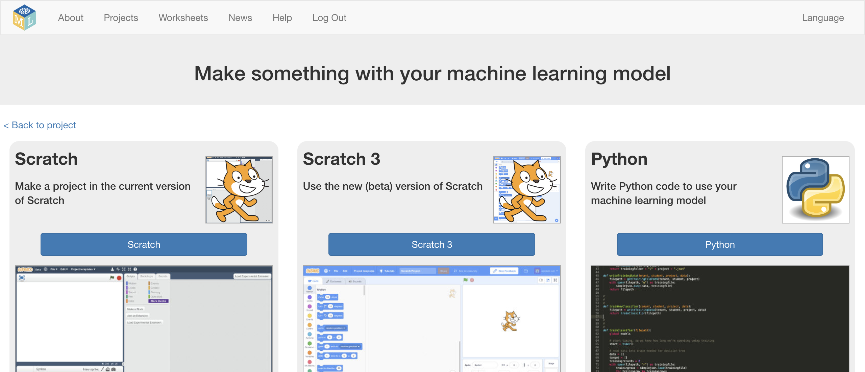
3. Click “**Open in Scratch**”
4. Click on “**Project templates**”  
   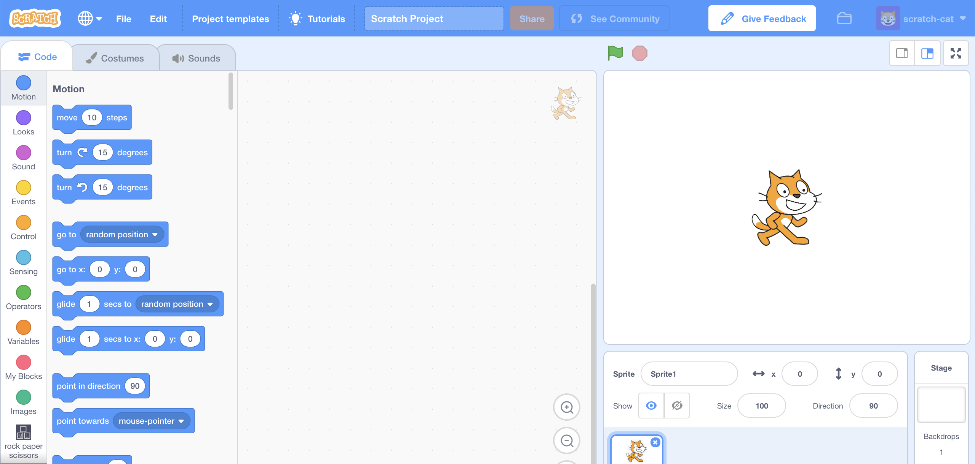
5. Click on the “**Rock Paper Scissors**” project template.   
   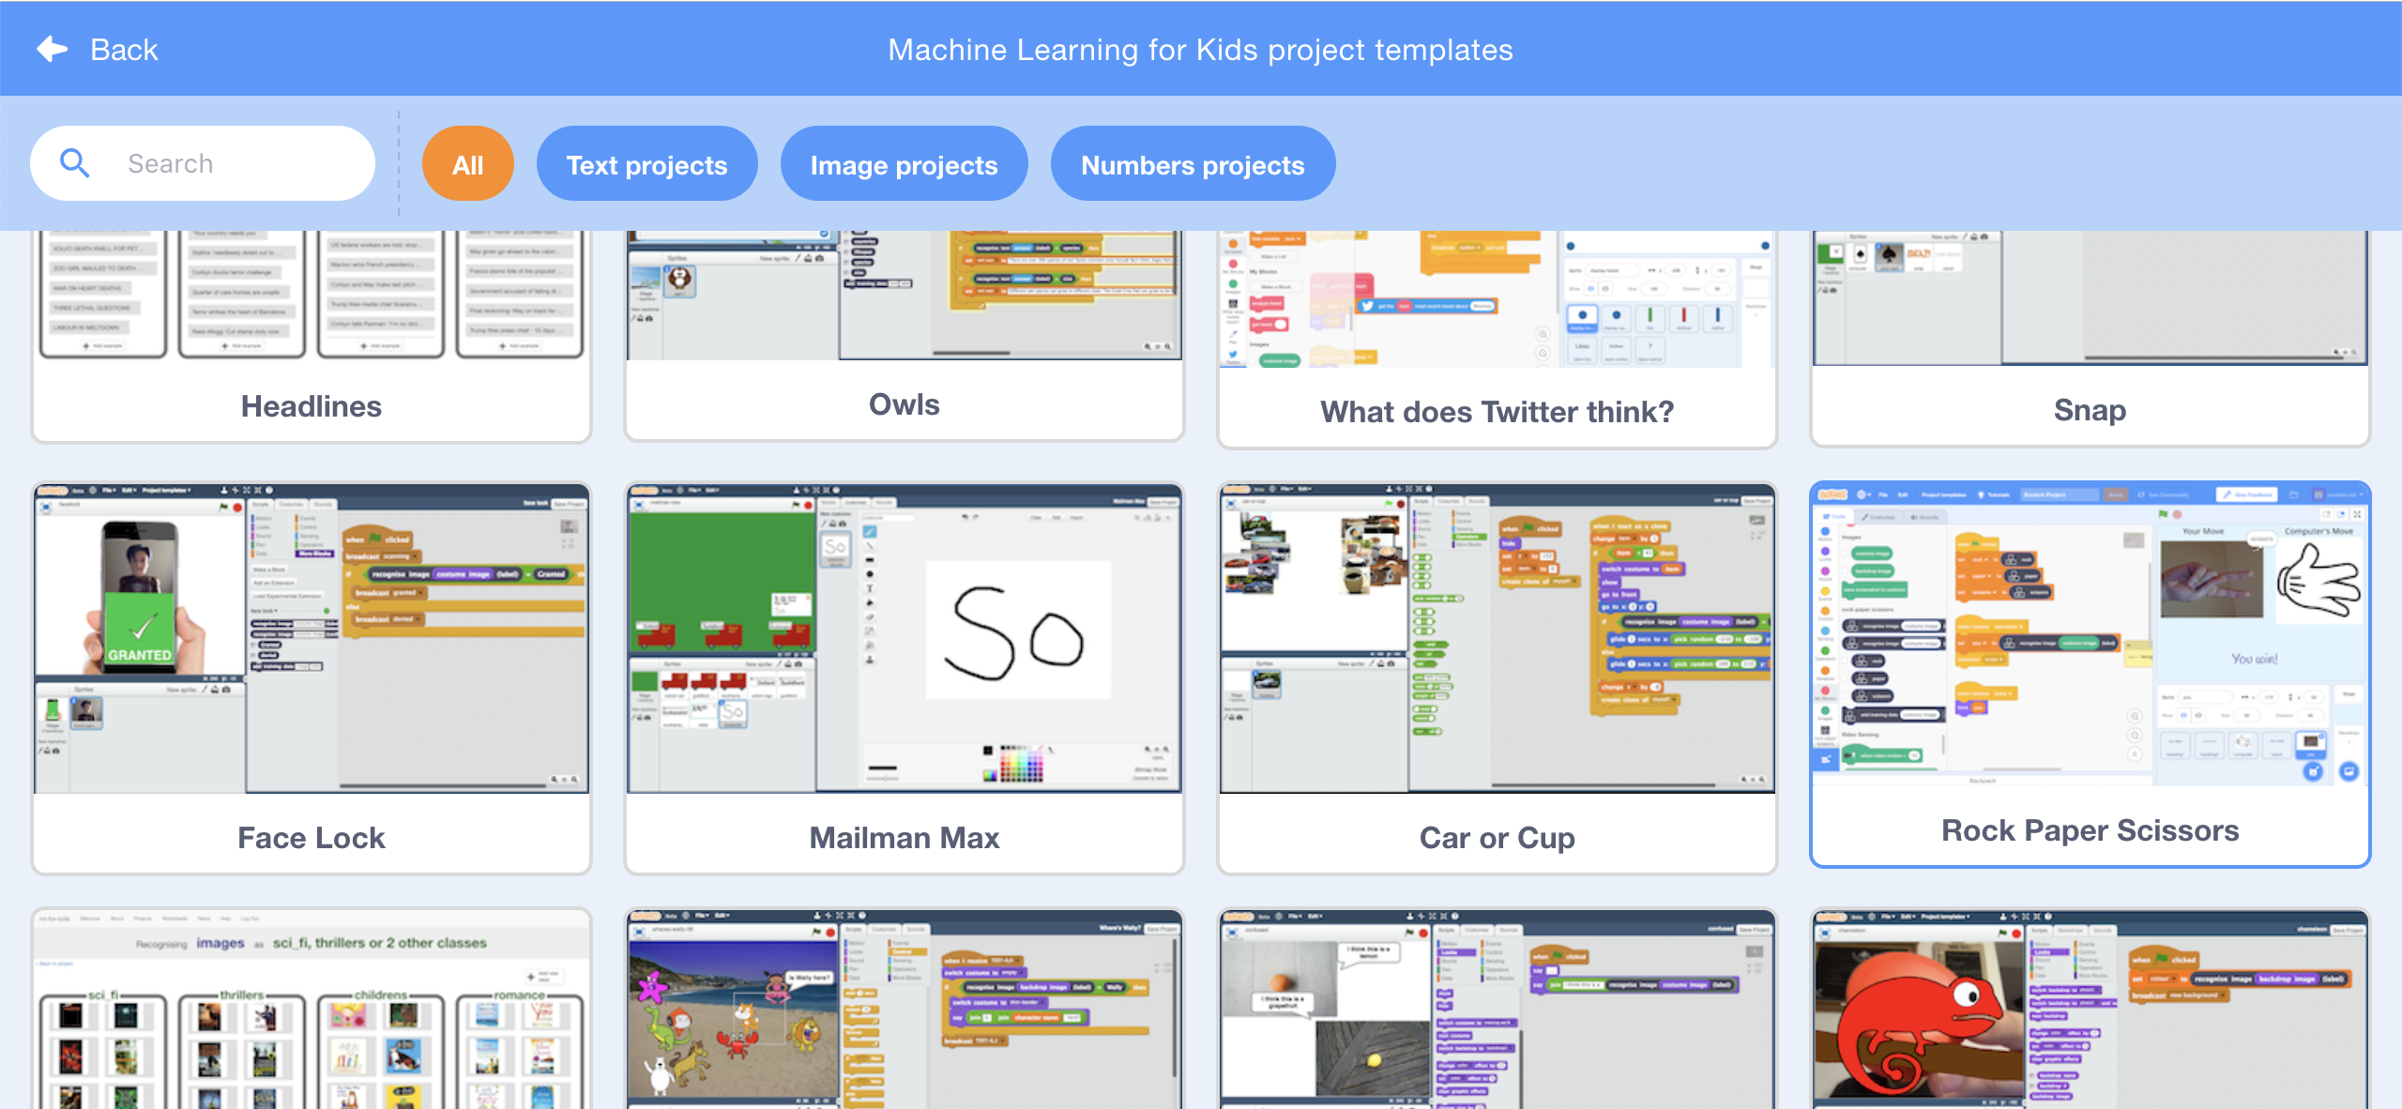
6. Click on the “**you**” sprite.  
   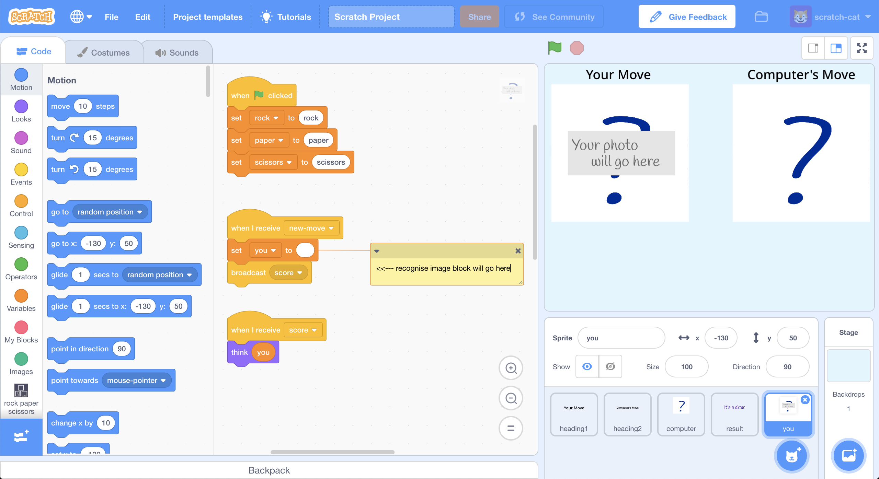
7. Update the **green-flag-clicked script** by adding your project blocks  
   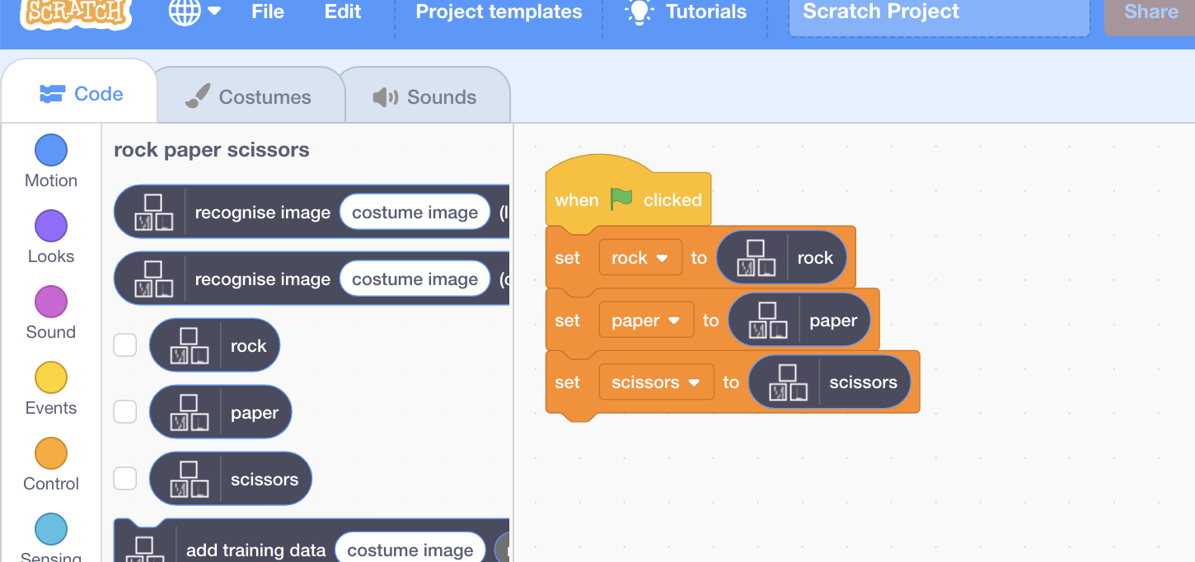
8. Update the **new-move script**   
   *Add the “****recognise image****” and “****costume image****” blocks*  
   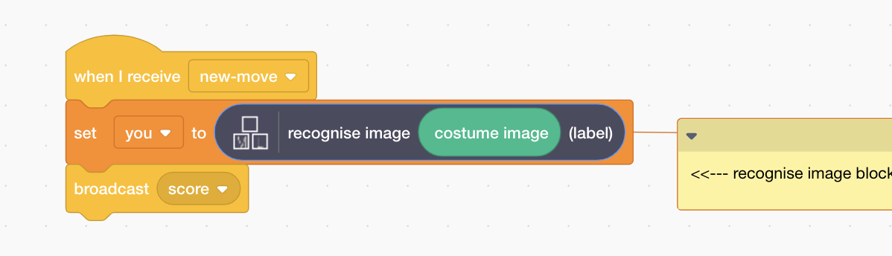
9. Test your project  
   *Click the* ***Green Flag****, then click press the “P” button to take a photo.*

*The computer will choose a random picture.   
It will try to recognise your hand shape, and then display who won.   
*

1. If the computer is not very good at recognising your hand shapes, go back to step ‎18, and add more examples for the computer to learn from.   
   You’ll need to ask your teacher to train a new machine learning model after you’ve added more examples.

**What have you done?**

You’ve made a simple rock-paper-scissors game in Scratch.

The game uses a webcam to take pictures of your hand, and uses machine learning to understand the meaning of the photo.

This is “image recognition” – teaching a computer to recognise images.